Problem1:-(hadoop 2)

when i ready to throwing data on HDFS using -put cmd it shows below error –

(add screenshot 1 and 2)

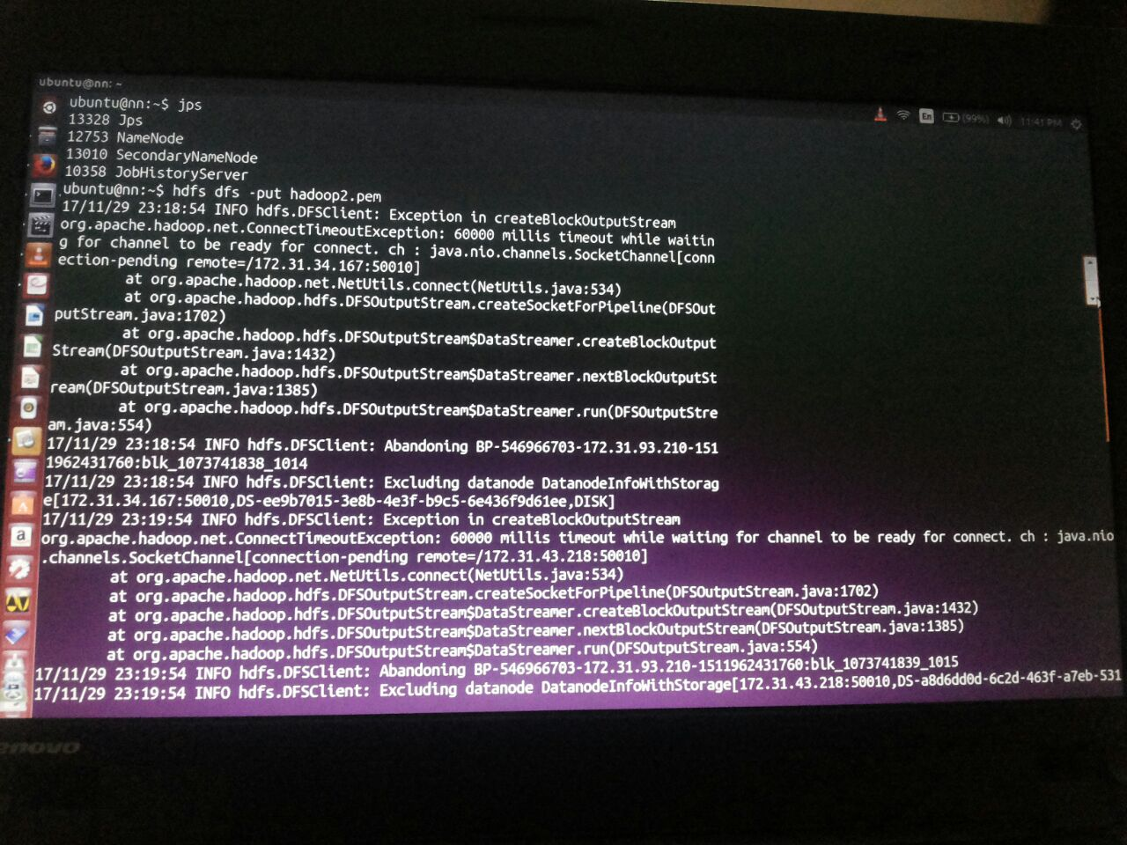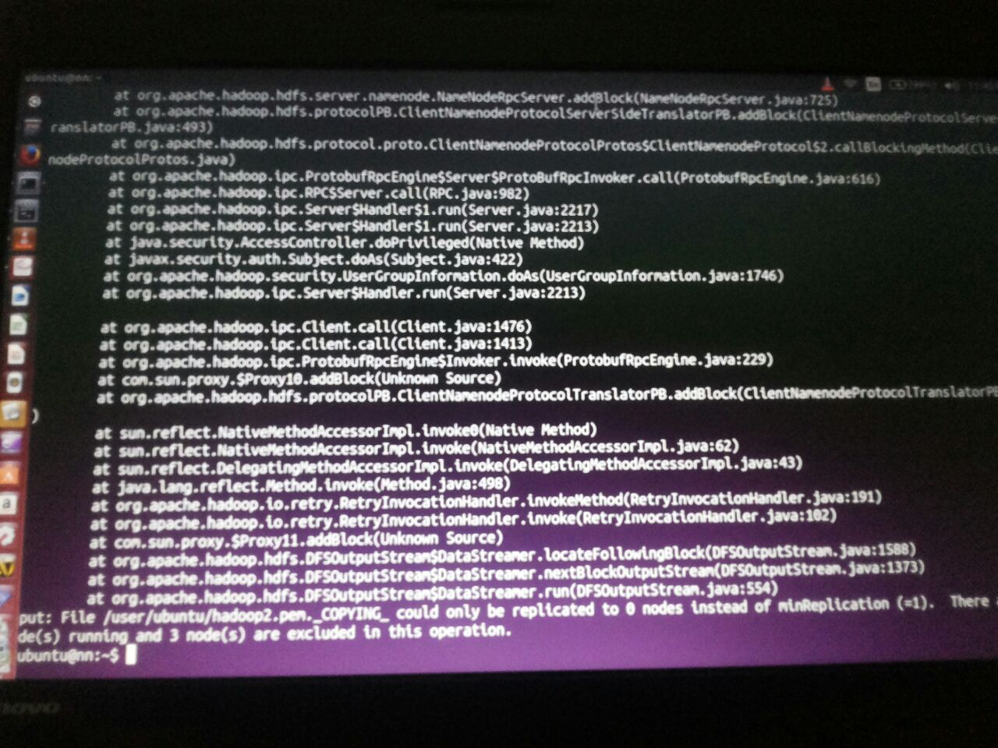

Solution- As discussed,

After creating snapshot i just roughly created 3 nodes RM, DN1, DN2 and one is NN which is already created. While creating this 3 nodes i forgot to change inbound rules thats whys i faced this problem. In test environment check your port type and source it should be all tcp and anywhere respectively.

See in screenshot -

(add screenshot 3 and 4)

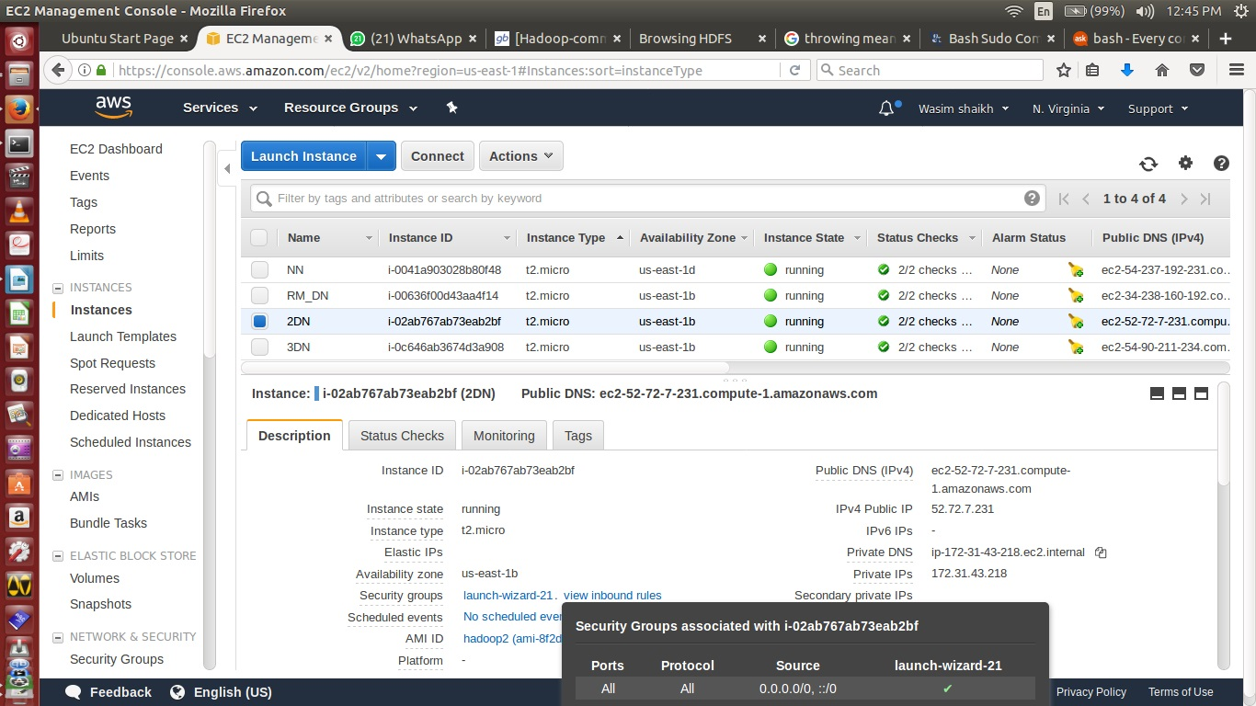

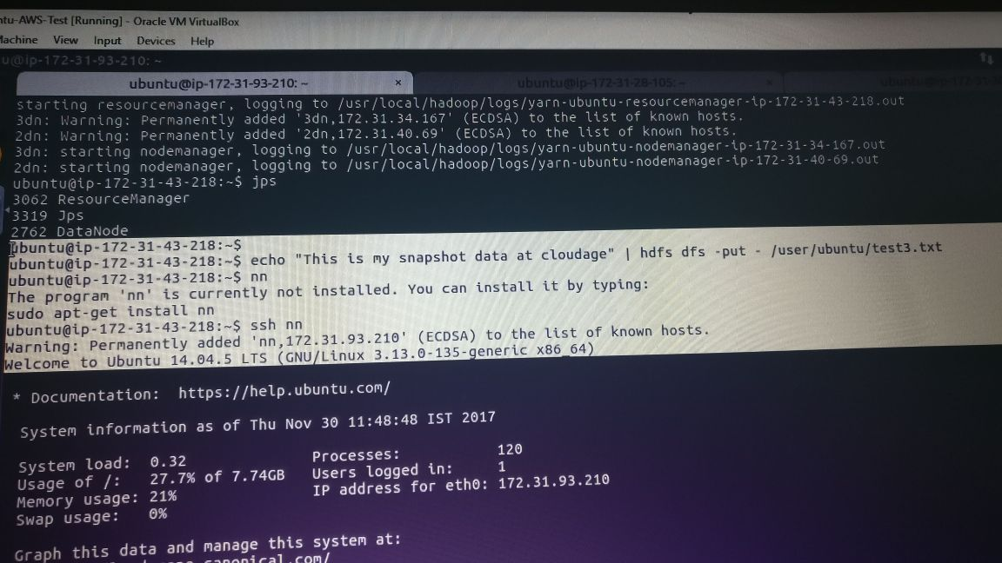

Problem 2:-

when something happan in .bashrc file or some changes done then it will give you below error to open .bashrc file.

-bash: sudo: command not found

-bash: bash: command not found

and more error see in screenshot

(add screenshot 5 )

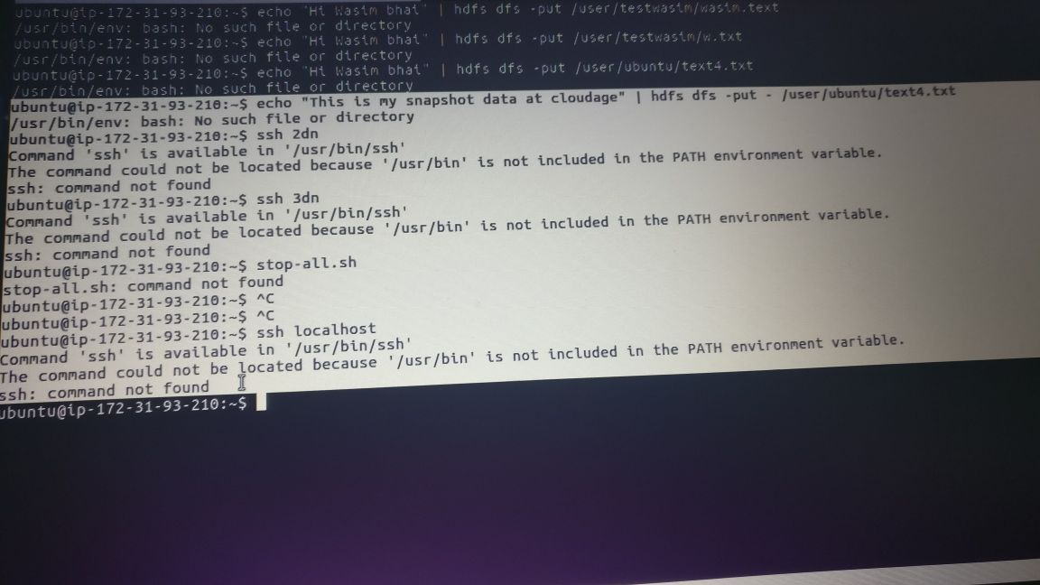

Solution:-

i tried to use full path

/usr/bin/sudo

if that command work then include /usr/bin/ in your env variable PATH in ~/.bashrc

echo "export PATH="$PATH:/usr/bin"" >> ~/.bashrc

hopefully works ..

but its not work then finally i login with another node and hit scp cmd.

(add screenshot 6)

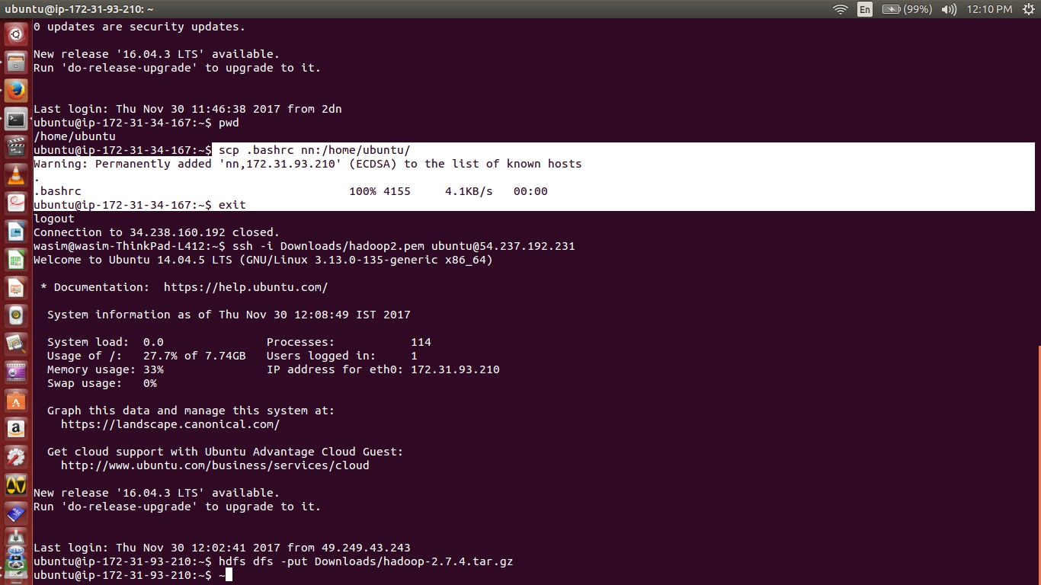

[12:07 PM, 11/30/2017] Rakesh Hadoop Classes: <http://grokbase.com/p/hadoop/common-user/103q35fysp/a-problem-when-starting-datanodes>

[11:01 AM, 11/30/2017] Rakesh Hadoop Classes: <https://dzone.com/articles/top-10-hadoop-shell-commands>